Module 8

Assignment 8.2
Course: CSD402-340A Java for Programmers
Prepared By: Mirach Erkol
Date of Report: 2/21/2026

https://github.com/Mikey5007/csd-402.git

8.2 Assignment:
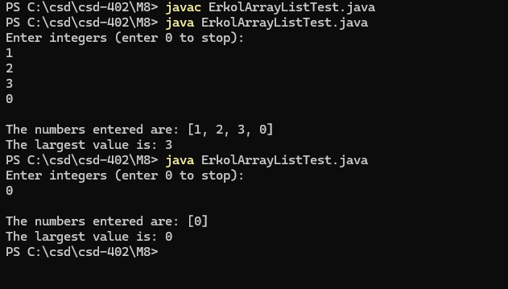

References:

https://github.com/Mikey5007/csd-402.git

